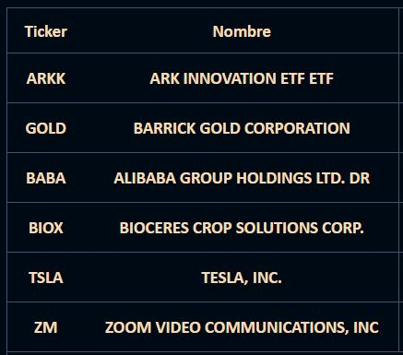

**Ticker**

**Nombre**

ARKK

**ARK INNOVATION ETF ETF**

**GOLD**

**BARRICK GOLD CORPORATION**

**BABA**

**ALIBABA GROUP HOLDINGS LTD. DR**

**BIOX**

**BIOCERES CROP SOLUTIONS CORP.**

**TSLA**

**TESLA, INC.**

ZM

**ZOOM VIDEO COMMUNICATIONS, INC**